**How to check out privileged account from CyberArk PAM**

Login to your WVD instance : DVC.Dow.Com

Browse <https://pam.intranet.dow.com/> (Preferably Chrome or Edge)

MFA notification will be sent to your registered mobile.

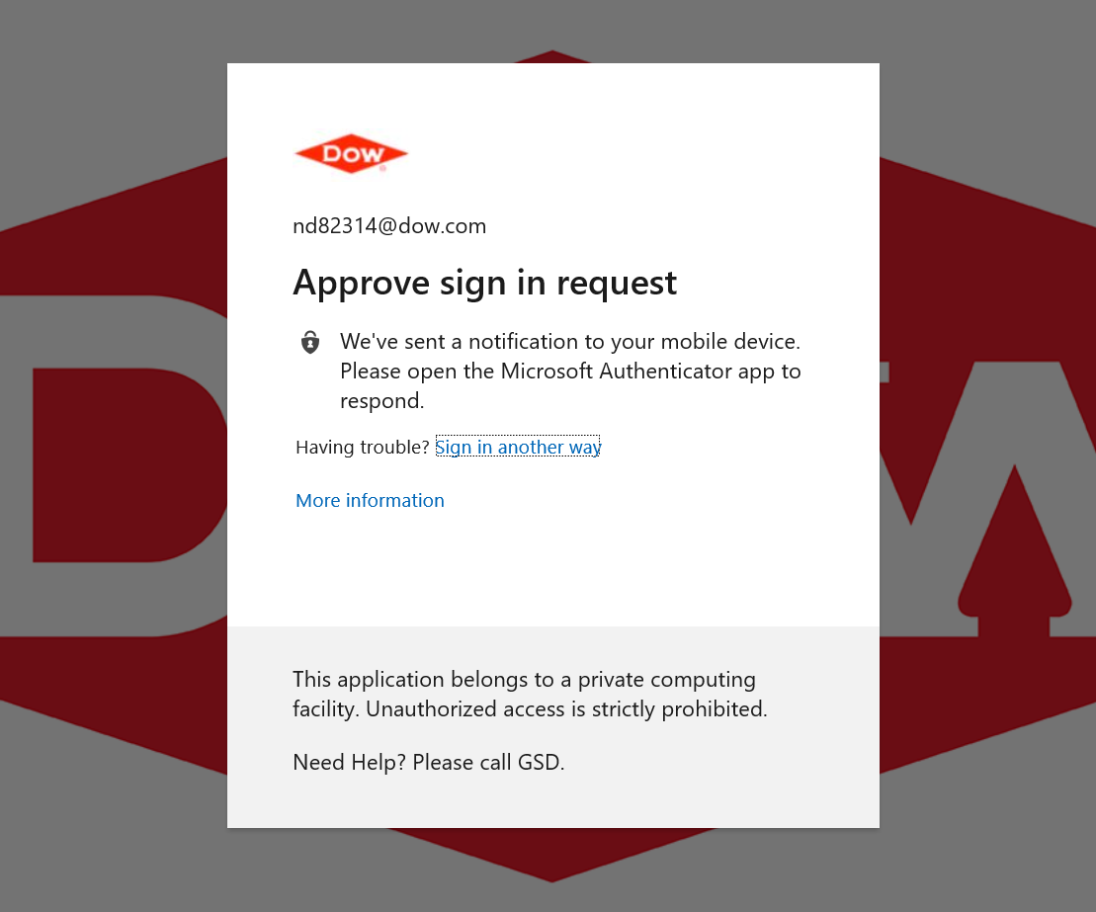

Once approved, following page will be displayed

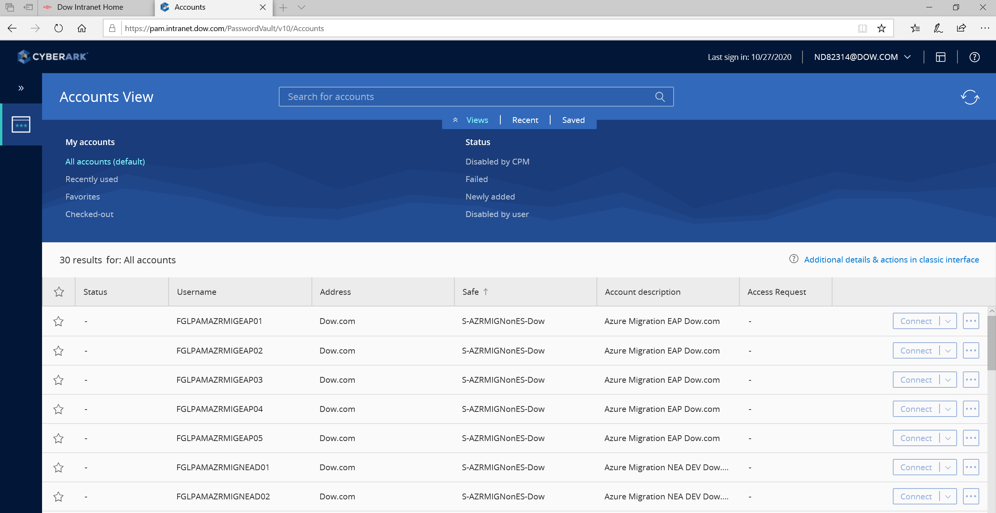

This contains list of accounts available for each domain and environments. (for example, Dow.com DEV and PROD)

Every environment will 5 accounts.

To check out an account, select the account and then click on 3 dots (next to connect). Then click on Show.

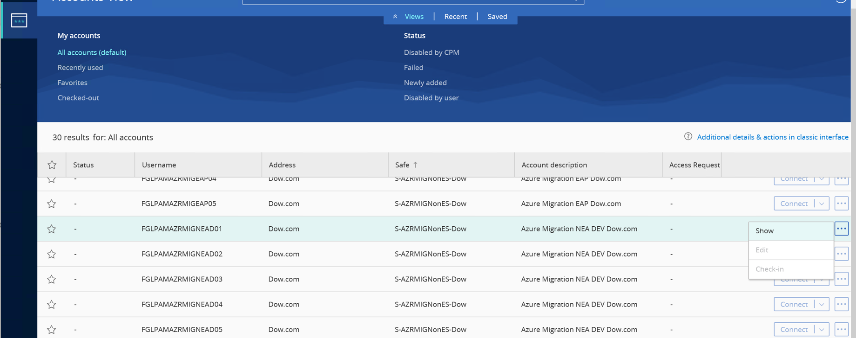

Enter the details accordingly and click on Show.

Note: Ticketing ID should be Service Request/CR number that has been created for application migration.

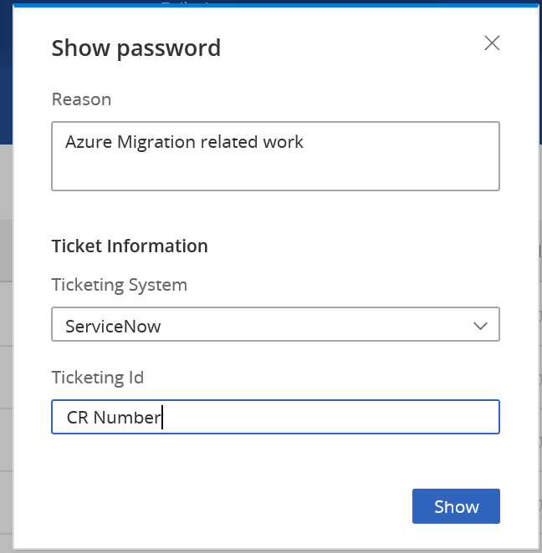

Copy the password displayed and click on close.

The password is valid for 9 hours from the time of checkout.

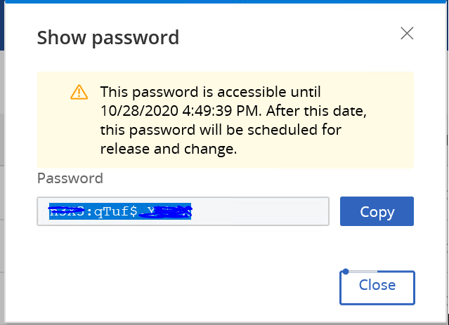

Open RDP and try to connect to remote server.

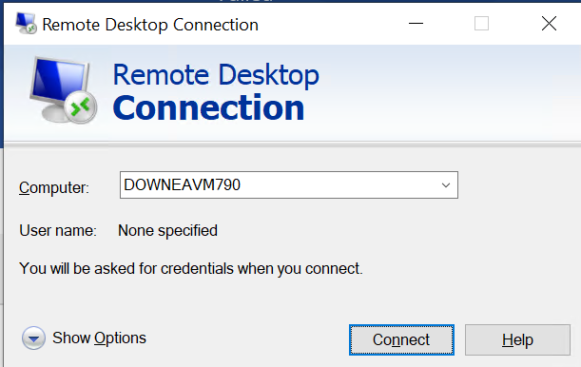

Enter the username and password that you have checked out.

Note: Make sure to manually type DOW (domain name) before computer name. otherwise will get an error.

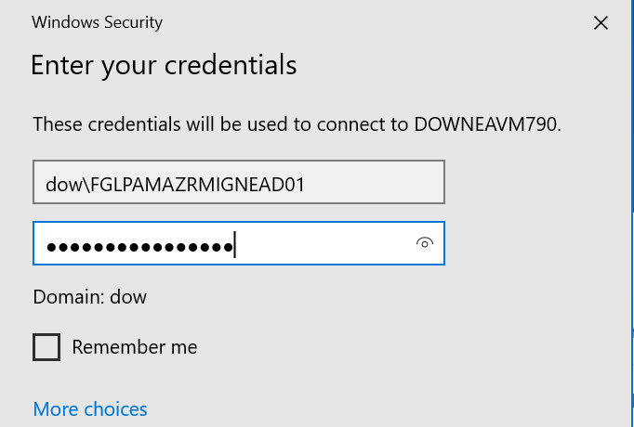

Now you should be able to login to remote server with admin access.

***Additionals:***

If account is already checked out by someone else, a lockpad icon will be displayed. Hover over it to find the user name who has checked out the account.

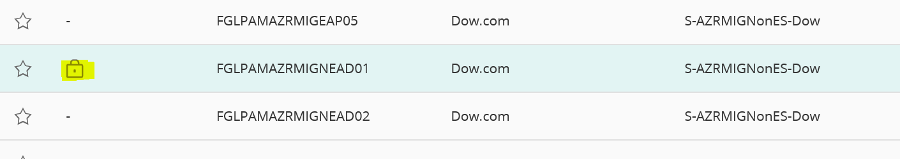

You can also check-in account once you are done with your work.

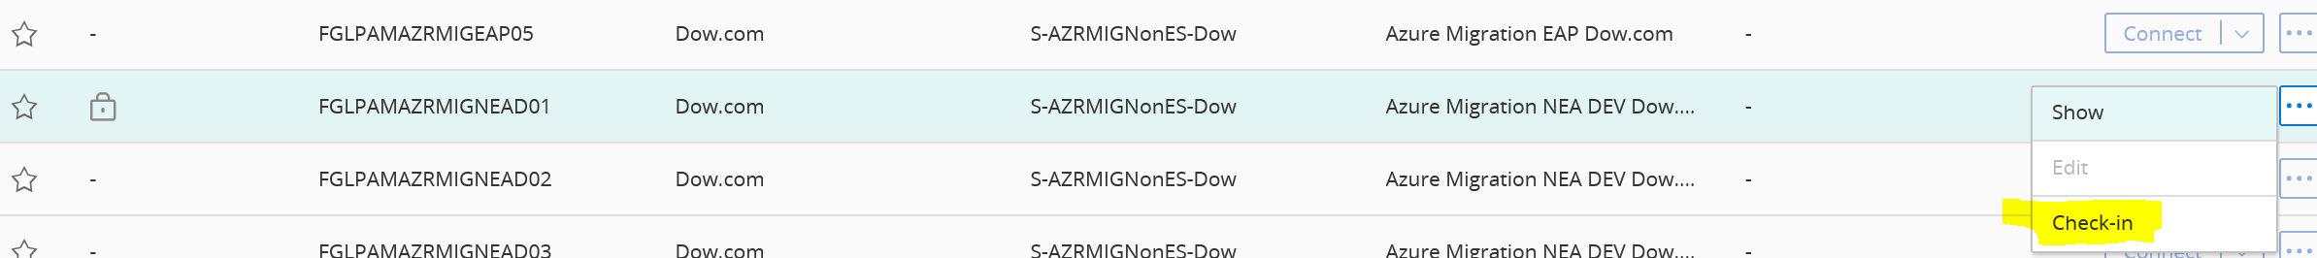

***Dow Intranet article***

<https://dow.service-now.com/sp?id=kb_article_view&sysparm_article=KB0033124&sys_kb_id=69f4a21a1b0c2410eed5cb7f034bcb49>